

**ADVANCED PROGRAMMING**

**PROJECT PROPOSAL**

**Project Title:** *BASIC AI*

**Group Members:-**

1. Mujtaba Shahid Faizi #131818
2. Ziyab Ikram #121923
3. Muhammad Ehsan Khan #120576

**Introduction to the problem area:-**

The field of Artificial Intelligence(AI) is advancing rapidly and being applied in many of the daily-life routines. Starting from mere face recognition softwares, to automated cars; AI has proved to be somewhat helpful to mankind in solving the biggest of problems. The knowledge of AI is proving to be very vital to people. University students, in their initial semesters have no idea about the basic concepts of AI which enables them to use their time in first learning AI rather than implementing it.

Therefore, we have decided to create a mobile app providing a very easy interface, to show the basic concepts of AI, mainly machine learning.

1. First providing the tips/explanation with examples ofcourse, regarding the terms and algorithms used in AI.
2. Then providing options of selecting some term/algorithm; say options: Neural Networks & Decision Trees. Both will show some explanation and examples. The algorithms will ask for simple inputs say input values, no. of iterations and step-size constants to explain the working of the algos. They will be able to observe the changes in output by experimenting with different parameters.
3. The students will understand the various model improving techniques.
4. In the image analysis domain, students will be able to upload their pictures and see their histograms structure, how to identify various important features in them and whatnot.

. 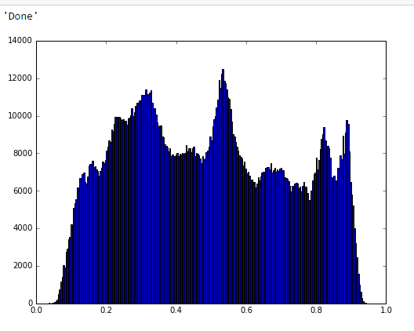

1. The app will allow automatically calculating and showing the output by using formulas e.g. for updating weights to get minimum error in output (stochastic gradient descent).

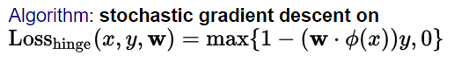

**Target Audience:**

The audience in this case, would be the students of K-12. Different schools may refer this app to the students for self-learning or add it as a tool for usage in computer course.

**Need Analysis:**

The teachers in different schools will have comfort in teaching the computer course since the app will provide all the necessary functionalities to learn AI without them having to lift a finger. Soon, the term AI will reach young children as well and their curiosity will lead them in learning what AI means. This app will ease them into the various aspects of artificial language.

**Problem Statement:**

Teach the students basic concepts of Artificial Language.

**Solution:**

Creating a mobile application to explain and interact with the domain of AI algorithms.

**Solution's Novelty:**

The mobile application is easy to use and all the core concepts will be available rather than explaining a particular field like computer vision or deep learning. The concepts will be accompanied by explanation and examples. The main structure & complexity will be depicted by graphs, images and formulas.

**Timeline of Completion:**

5weeks divided in

Architecture & planning-*1 week*

UI Designing-*1 week*

Development-*2.4 weeks*

Testing & Modifications-*3 days*